|  |  |  |  |
| --- | --- | --- | --- |
| Document filename: | **FHIR Clinical and Technical Assurance Process Guide** | | |
| Project / Programme | **Interoperability and Standards** | Project | **<insert>** |
| Document Reference | **<insert>** | | |
| Project Manager | **<insert>** | Status | **Draft** |
| Owner | **Dr Munish Jokhani** | Version | **0.91** |
| Author | **Dr Munish Jokhani** | Version issue date | **06/03/2020** |

Published 09 March 2020

FHIR Clinical and Technical Assurance Process Guide

Document management

Revision History

|  |  |  |
| --- | --- | --- |
| Version | Date | Summary of Changes |
| 0.1 | 12/08/2019 | First draft |
| 0.2 | 13/08/2019 | Second draft; updated after review comments |
| 0.3 | 14/08/2019 | Updated after review comments |
| 0.4 | 02/10/2019 | Added scope section |
| 0.5 | 09/10/2019 | Updated after comments |
| 0.6 | 22/11/2019 | Updated after comments from Senior Clinical Lead |
| 0.7 | 17/01/2020 | Further edits to align with the UK FHIR core assurance |
| 0.8 | 31/01/2020 | Further edits to align with the UK FHIR core assurance |
| 0.9 | 06/03/2010 | Edits after review comments |
| 0.91 | 09/03/2019 | Reviewed by the FHIR Core SLT |

Reviewers

This document must be reviewed by the following people:

|  |  |  |  |
| --- | --- | --- | --- |
| Reviewer name | Title / Responsibility | Date | Version |
| Chris Dickson | Senior Clinical Lead | 12/08/2019 | 0.5 |
| Kevin Sprague | Interoperability Lead | 12/08/2019 | 0.6 |
| Dave Crampin | FHIR Product Owner | 13/08/2019 | 0.8 |
| Andrew Meyer | Programme Director | 09/10/2019 | 0.3 |
| Lucy Killick | Senior Project Manager | 02/12/2019 | 0.6 |

Approved by

This document must be approved by the following people:

|  |  |  |  |  |
| --- | --- | --- | --- | --- |
| Name | Signature | Title | Date | Version |
|  |  |  |  |  |
|  |  |  |  |  |

Glossary of Terms

|  |  |
| --- | --- |
| Term / Abbreviation | What it stands for |
| FHIR | Fast Healthcare Interoperability Resources |
| Generic Profile | A FHIR profile which has been derived directly from a FHIR resource. This may also be referred to as a level 2 profile. The generic profile should have been created for general use across most known use cases and not for a specific use case. Seen to be very reusable. The CareConnect profiles are an example of generic profiles. |
| Level 3 Profile | A FHIR profile which has been derived from a generic (level 2) profile for a specific use case or use cases. Generally seen to have little or no reuse. |
| Core Profile | A generic profile that is included as part of the Core pack. This is currently the CareConnect profiles. |
| FHIR Assets | The collection of FHIR Resources that consist of Profiles (Structured Definitions), ValueSets, CodeSystems, ConceptMaps, OperationDefintions, SearchParameters, Extensions, NameSystems. |
| Generic Core | The current name of the core specification. The final name of the specification is subject to further discussion. |
| DDM | Design Decision Matrix, used in the curation process, a google sheet where key design decisions were recorded. |

Document Control:

The controlled copy of this document is maintained in the NHS Digital corporate network. Any copies of this document held outside of that area, in whatever format (e.g. paper, email attachment), are considered to have passed out of control and should be checked for currency and validity.

**Contents**

1 Audience 5

1 Purpose 5

2 Background 5

3 Why do we need it? 6

4 What is FHIR Clinical and Technical Assurance? 7

4.1 Scope 7

4.2 Link to UK Core 8

5 How does it work? 9

5.1 Publication of the UK core pack (1.0) 9

5.2 External consultation (2.0) 10

5.3 Update specifications (3.0) 10

5.4 Handover to the UK core change control process (4.0) 10

5.5 Review and approve FHIR assets (5.0) 10

5.6 Produce hazard log and Clinical safety report (6.0) 11

6 Where do I start? 11

6.1 Setting up meetings 11

7 What are the key outputs? 11

8 How do we get involved? 12

8.1 Via Simplifier 12

8.2 Contact Us 12

9 Appendix A: Roles and Responsibilities 13

10 Appendix B: Example use case 15

11 Appendix C: Review Pack Template 16

12 Appendix D: FHIR Core SLT Terms of Reference 16

# 1 Audience

The audience of this document are internal NHS Digital programmes and external stakeholders and implementation sites using FHIR specifications. It is assumed that the reader has a basic understanding of [HL7 FHIR](https://www.hl7.org/fhir/).

# Purpose

The purpose of the document is to describe the FHIR clinical and technical assurance process. The process builds on the previous version of the process known as INTEROPen FHIR curation process and includes changes to align it with the new FHIR UK core review.

INTEROPen is an OPEN collaboration of individuals, industry, standards organisations and health and care providers, who have agreed to work together to accelerate the development of open standards for interoperability in the health and social care sector.

The FHIR UK core pack and downloadable FHIR assets will be created using the FHIR tooling used for the FHIR standard and the US and AU core specifications. This is adopting a similar approach as used by the US Core profiles <http://www.hl7.org/fhir/us/core/>.

# Background

Founded in 1987, Health Level Seven International (HL7) is a not-for-profit, ANSI-accredited standards developing organization dedicated to providing a comprehensive framework and related standards for the exchange, integration, sharing, and retrieval of electronic health information that supports clinical practice and the management, delivery and evaluation of health services. HL7 UK is the UK affiliate organisation to HL7 and was set up in January 2000.

FHIR® – Fast Healthcare Interoperability Resources (hl7.org/fhir) is a next generation standards framework created by HL7. FHIR combines the best features of HL7's v2, HL7 v3 and Clinical Document Architecture (CDA) product lines while leveraging the latest web standards and applying a tight focus on implementability. FHIR solutions are built from a set of modular components called "Resources". These resources can easily be assembled into working systems that solve real world clinical and administrative problems at a fraction of the price of existing alternatives.

A FHIR Profile is a set of constraints on a resource. A "constraint" specifies a set of restrictions on the content of a FHIR resource or data type, or an additional set of constraints on an existing profile. For example:

* Restricting the cardinality of the element; e.g. the base might allow 0..*, and a particular application might support 1..2
* Restricting the contents of an element to a single fixed value
* Specifying a binding to a different terminology value set
* Declaring that one or more elements in the structure must be 'supported'

The verb 'profile', or 'profiling', is used to describe the process of creating a profile.

The current published version of the FHIR is [Release 4](http://hl7.org/fhir/r4/) which was published in December 2018. The version before release 4 was Standards in Trial Use (STU)3 or Release(R)3. For all previous versions, please visit <http://www.hl7.org/fhir/directory.cfml>.

The FHIR Care Connect profiles were previously classified to describe the level of constraints applied on them as follows:

* **Level 1**: International FHIR baseline profile.
* **Level 2:** These are derived from Level 1 profiles and inherit all the constraints of Level 1 profiles. These are generic profile created for the UK core pack, these will include country specific constraints e.g. NHS number, Terminology bindings.
* **Level 3**: These are derived from Level 2 profiles and inherit all the constraints of Level 2 profiles. Further constraints are applied at this level which are use case specific e.g. Digital Child health or transfer of care.

The links between FHIR resources, profiles and FHIR UK core profiles are described below in the diagram:

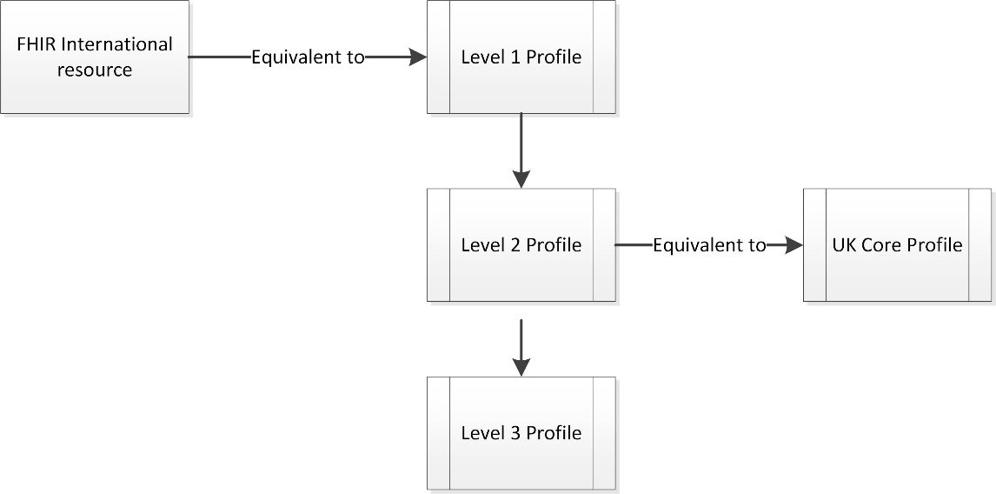

# Why do we need it?

The process will produce a FHIR assets that are **fit for purpose** as it has had clinical, clinical informatics, clinical safety, terminology, technical and vendor input. The key value add is multi-disciplinary collaboration in an agile team and ability to improve quality of the product. Without the technical and clinical assurance process, there is hand over of requirements from business team to technical modellers to produce a specification which might not meet business requirements.

It **helps those who will be implementing** the specifications understand the rationale and details behind the design. The vendors are engaged as part of the process which means they can raise implementation issues and resolve these issues before the specifications are published. The process also challenges the clinical requirements where they are insufficiently detailed, resulting in a more robust definition. The process provides a feedback loop to the business/programme team to update clinical requirements as needed.

The process **supports consistency** in the FHIR assets across different programmes and use cases to support interoperability. There is a risk that the programmes might develop FHIR assets which conflict with previous design decisions. The process ensures that the design decisions used previously are consistently applied and any reasons for divergence are documented and justified in a transparent way.

# What is FHIR Clinical and Technical Assurance?

In the FHIR clinical and technical assurance process, a team of subject matter experts map use case specific clinical information models, for example, allergies and adverse reactions to the AllergyIntolerance FHIR resource. This mapping produces a “profile” of the international resource. The curation process was working on [FHIR STU3 version](http://hl7.org/fhir/stu3/resourcelist.html) and the FHIR clinical and technical process will be used for the FHIR release 4 and onwards.

During this mapping process, a variety of decisions are made, for example, the use of appropriate terminology bindings, such as SNOMED CT.

From Clinical Assurance perspective FHIR assets are reviewed for:

-- Accuracy (clinical knowledge and clinical practices)

-- Validity (designed correctly for the purpose of clinical practice and clinical use)

-- Usability (useful and usable for the clinical story tested against)

For Technical Assurance the FHIR assets are reviewed for:

-- Conformance to the FHIR Standard

-- Adherence to the documented guidance for Creating UK Core FHIR assets

-- Correct usage of the FHIR assets for the use case

## Scope

The scope of the clinical and technical assurance process is described below:

* To provide collaborative opportunity to review FHIR resource proposal considering use case and data modelling and resolve any outstanding queries that require further clarity
* Identify areas of data modelling that are inconsistent with current health informatics/clinical practices
* Assess FHIR resource proposal in relation to use case and architectural pattern for clinical risk
* Review proposed design on how profiles reference/link with each other
* Mapping of value sets to FHIR value sets as appropriate
* Review alignment with UK core in terms of mappings, extensions and implementation guidance and highlight any changes from UK core
* Review search parameters and triggers points relevant to the use case

The following activities are not in scope, it is assumed they are completed as pre-requisite:

* Validation of use cases and business processes
* Validation of business data sets
* Review of data model with vendors

## Link to UK Core

The UK core assets are the foundation for future FHIR implementation guides and are based on the international standard that is common in other countries such as Canada, the US and Australia. The UK Core specification will be based on the Government Digital Service (GDS) Life Cycle:

Retiring

Live

Public Beta

Private Beta

Alpha

Discovery

The clinical and technical assurance process could ideally start in alpha phase assuming the discovery phase is complete with documentation of requirements including use cases, interaction diagrams, information models and patient journeys with clinical examples.

The actual start time of the assurance might differ depending on what stage a programme wants to initiate the process, and this means some programmes might start the assurance after private beta. The diagram below describes key stages in the UK Core development and how the Clinical and Technical (C& T) Assurance process fits with the UK Core:

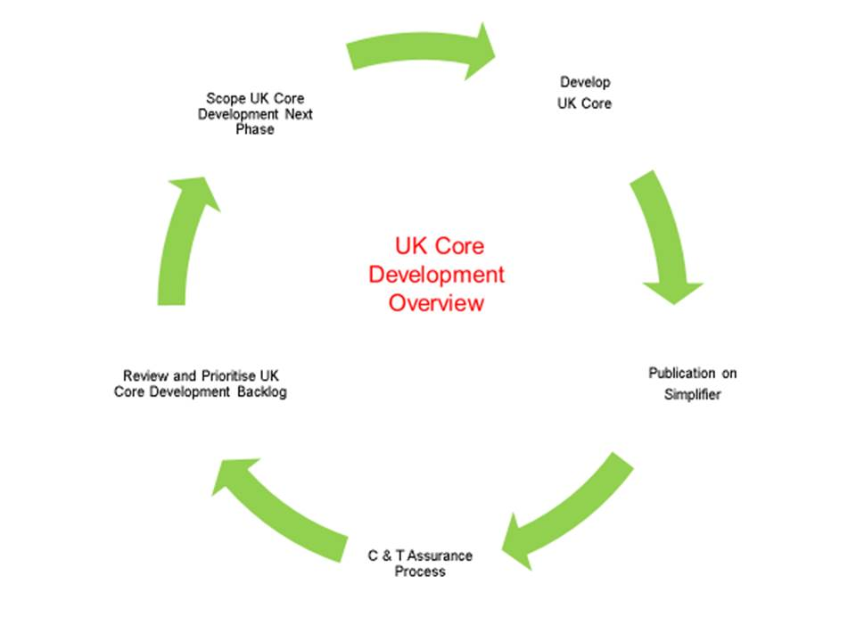

# How does it work?

The FHIR clinical and technical assurance process includes six steps which are described below. The clinical and technical assurance process team comprises of clinical leads, clinical informaticians, message modellers, terminology specialists, clinical safety, First of Type (FoT) representatives from programmes, implementation sites and vendors and information governance representatives if needed.

Several programmes could run the process in parallel improving the output of the process. Once profiles have been through this process once, it is expected that they will not need to go through the process for every use case or programme and will be stabilised by the use of the core which will use UK core profiles, with business rules added to implementation guides for further details. This will eventually shorten the process for all participants. Only new profiles will be discussed in detail. The change control and tracking of these will be managed by the UK Core development team (UKCDT).

The roles and responsibilities for the process is available in Appendix A.

The diagram below describes the key steps in the process, the description of each step below includes reference to the diagram in the title in brackets e.g. Publication of the core pack (1.0):

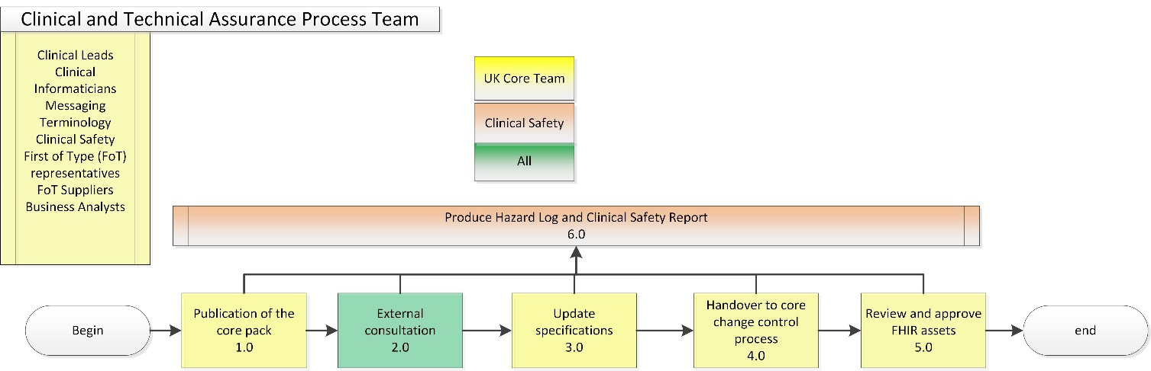

## Publication of the UK core pack (1.0)

The phase 1 involves creating a review pack for the external consultation which includes first draft of mapping by the UK core team. It is assumed that at this stage key inputs to the process are already complete, the key recommended inputs to the process are:

* Strategic Overview to include background, introduction to the programme scope, strategic objectives, vision and timelines
* Use Cases including description of clinical workflows and key interactions; please see Appendix B for an example use case.
* Clinically assured Information models/datasets
* Patient journeys with example clinical content
* Architecture overview to include FHIR paradigm e.g. REST, bundle, document and transport layer e.g. MESH
* Initial list of FHIR resources for use cases
* Initial plan including deployment approach
* List of engaged vendors and representatives from private beta site

The programme team will need to commit its resources to attend team calls, which are scheduled once a week; this includes one external community call per sprint. The team must provide their own clinical lead to own and sign off the final products. It is recommended that other programme resources e.g. business analyst, project manager and technical architect also join both team and external community calls.

The review pack will be created by the UK core development team within NHS Digital in collaboration with the internal and external stakeholders including First of Type (FOT) vendors and implementation sites representatives. The core pack will be discussed internally by the core team to include design options and recommended option over several calls as required. The core team will create a recorded call/video to explain key decisions required from the external stakeholders.

The review pack will include FHIR Assets (Profiles, Value Sets, Code Systems etc), implementation guidance, links to training material and for FHIR.

## External consultation (2.0)

The review pack will be released for consultation with external stakeholders for a period of 15 days with an ability to provide comments via Simplifier. The review pack release will be notified on several channels e.g. email, Ryver, Simplifier news as appropriate.

After the review period, the UK core team will review the comments and agree on resolutions which will be presented on an external call to the stakeholders. The scope of discussion on the consultation call is limited to the issues raised as review comments in the consultation phase. If there is no consensus on the consultation call, this will be escalated to the FHIR Core Senior Leadership Team (SLT) to make decisions. Please see Appendix D for the Terms of Reference of the SLT. This team will engage with the UK FHIR community and seek input as needed.

## Update specifications (3.0)

The UK Core development team will update the specifications in a future release based on agreement on the external call or further agreement with the SLT if required. This might require another call with UK core team on agreeing the changes in the specifications.

## Handover to the UK core change control process (4.0)

This will follow the change control process for the UK core and associated specifications.

## Review and approve FHIR assets (5.0)

The updated FHIR assets will be presented back to the community for approval that the changes as agreed in the external consultation have been applied to the FHIR assets. The final decisions on the specifications will be agreed at the SLT.

## Produce hazard log and Clinical safety report (6.0)

An initial hazard log will be produced in parallel as per the NHS Digital Clinical Safety process to identify any clinical risks associated with the proposed design and an associated clinical safety report will be produced. The hazard log and the clinical safety report will be presented to the NHS Digital Clinical Safety Group for endorsement. The clinical safety hazard log and report will be aligned with the programme specific hazard log and report where relevant to avoid duplication of effort.

# Where do I start?

* First step is to decide if the programme/project is ready for the clinical and technical assurance process working with the UK Core development team. The programme/project is recommended to engage with the UK Core development team to prepare a review pack with key process inputs. The template for the review pack is available in the Appendix.
* At the same time the project manager could start preparing the schedule. The programme/project needs to estimate the number of sprints depending on the scope of the project.
* The programme/project needs to set up a New Work Request with the UK core development team. The programme should raise separate resource request for terminology, clinical safety and the clinicians.  The terminology resources are under Information Representation Services (IReS).
* Engage with First of Type representatives and vendors to establish if they would like to be part of the clinical and technical assurance process team and have availability to attend the meetings.

## Setting up meetings

* Once funding and resources are confirmed, the next step is to set up the meetings using MS Teams and send communication to the UK core team that the sprint is planned, and they should be expecting diary invites. In parallel, prepare a communication for external stakeholders working with the UK Core development team. Decide who is going to chair the core team meetings and the external calls.
* Decide who is going to start/host the core team meetings and external meetings, who is going to record them, take meeting notes, manage action log and complete the technical documentation.

# What are the key outputs?

The example outputs of the process are:

* Assured UK core profiles
* Assured SNOMED CT/dm+d value sets/resets
* Assured Implementation guidance
* Agreed changes in the proposed business logical models
* Clinical Safety Report and Hazard log

# How do we get involved?

## Via Simplifier

The UK Core FHIR assets are published on Simplifier at:

<https://simplifier.net/ukcore>

The UK Core FHIR Implementation Guides are published on Simplifier at:

<https://simplifier.net/UKCore/~guides>

If you don’t have a simplifier account you can register at <https://simplifier.net/signup>

## Contact Us

If you require further information, please email our support mailbox at interoperabilityteam@nhs.net

# Appendix A: Roles and Responsibilities

UK core development team:

* To update/maintain technical documentation in Simplifier
* To prepare review pack for the call/core team meetings to include profiling questions and technical options for decisions for the attendees working with the programme/business team.
* To agree on the technical design decisions for changes to the UK Core profiles working in collaboration with the team.
* To act as FHIR technical SME to answer questions on FHIR constraints, proposed extensions and design principles
* Develop draft domain Implementation guidance and release for review before publication of the specifications.
* To post on Zulip for feedback required and liaise with HL7 UK if required.
* Publish FHIR profiles and the specifications.

Project Manager (UK core development team or from the Programme/project)

* Lead on creation of review pack
* Publish draft agenda for the external calls
* To initiate MS teams, call and set it record
* Publish recordings
* Manage the schedule and pipeline working with the chair
* Action log reporting
* Track the delivery of:
  + UK core profiles
  + Agreed SNOMED CT/dm+d value sets/refsets
  + Implementation guidance
  + Changes in the proposed information models
  + Clinical safety report and hazard log

NHS Digital Clinical Safety team (to be resourced from the Programme)

* To lead on identifying clinical safety issues in the workshop
* To develop and maintain a hazard log of clinical safety mapping issues to be addressed further by the group and / or in a clinical safety workshop
* To complete hazard log and clinical safety closure report for the process
* To obtain endorsement from the NHS Digital clinical safety group for the release of the specifications

NHS Digital Terminologist:

* To identify appropriate value set of SNOMED CT, including dm+d, or gaps, as required
* To explain the design principles of SNOMED CT value sets
* To agree on design decisions to use FHIR or SNOMED CT value sets
* To provide clinical terminology and clinical informatics advice

Clinical lead (Programme e.g. Digital Medicines)

* To present use cases including description of clinical workflows and key interactions. Provide Patient journeys with example clinical content
* Describe Information models/datasets
* To inform clinical design decisions as part of the process: what might be the clinical safety implications on clinical workflows and clinical interpretation of data exchanged, when looking at the intended use of information models and the design principles of FHIR standards, and mapping decisions being made (clinical assurance)
* To provide a critical lens to question the real-world usefulness and safety implications of data identified in information models and exchanged using FHIR or SNOMED CT (clinical assurance)
* To help identify the risk of never events that might occur during the assurance of clinical information models onto the FHIR technical standard, and offering appropriate clinical safety mitigations (clinical assurance)

FHIR Clinical Assurance Lead/Chair (Clinical informatician with FHIR expertise)

* To lead on implementation of the clinical and technical assurance process
* To chair the UK core team meetings and external call and help prepare the review pack
* To ensure that the programme team and presenters are adequately prepared for the external call
* To work with the Project Manager on the pipeline and schedule of the future activities
* Manage the overall assurance process working with technical leads and look for improvement opportunities

Senior Clinical Lead (accountability)

* To provide overall clinical oversight to the process
* To inform clinical design decisions (clinical assurance)

Suppliers

* to write and inform design decisions on consultation calls
* to provide practical real-world implementation insight (Limitations, Complexity)
* to inform assurance

Technical Architect

* From the Programme e.g. Digital Medicines and/or National capability e.g. national record locater
* To provide technical architecture overview for the programme.
* To answer any queries related to Technical architecture

Business Analyst (Programme e.g. Digital Medicines)

* To prepare use cases and clinical scenarios working with the programme clinical lead
* To understand and document use cases

# Appendix B: Example use case

**NHS Urgent Medicine Supply Advanced Service (NUMSAS)**

|  |  |
| --- | --- |
| **Priority Use Case:**  **NUMSAS** | * **Over 7500 NUMSAS referrals occurred nationally in November 2017** * NHS111/IUC Clinical Assessment Service will refer patients to a community pharmacy (currently using an ITK or NH mail message) * If applicable the patient is supplied with the medicine/appliance by the pharmacy, details are recorded locally (electronically or on paper) * GP Practice is notified of the supply using electronic “post event message” (currently email). |

|  |  |
| --- | --- |
| **User Story** | **As a** pharmacy contractor,  **I can** notify the patient’s registered GP Practice of the emergency supply of a medicine/appliance,  **So that** the details of the supply of the medicine/appliance is:   * Received by the GP System of the patient’s registered GP Practice. * Integrated into the patient’s GP Record and/or GP workflow |
| **Background/ Current Process** | * Pharmacists may provide an emergency supply of a medicine/appliance to a patient, at the request of the patient or at the request of a prescriber. * The commissioning of emergency supplies varies. The emergency supply may be commissioned via a national NHS England service, locally commissioned or may be paid for privately by the patient. * Community pharmacies legally must maintain a local record of an emergency supply of a medicine/appliance to a patient, which can be recorded electronically in a local pharmacy system or on paper. * The patient’s GP Practice may or may not be notified of the emergency supply depending on the nature of the service. |
| **Actors** | * Patient * Pharmacist – the individual who supplies the medicine(s) and records details of the emergency supply. * MESH – Messaging System. * (Sending) Pharmacy System – the pharmacy system where details of supply are recorded and which sends the supply information to the patient’s registered GP System. * GP Practice System – the GP System of the patient’s registered GP Practice. |
| **Main Flow**  **(this may vary according to the commissioned service)** | 1. The Patient or Carer presents at the pharmacy. 2. The Pharmacist deems the request for emergency supply valid and appropriate and supplies the medicine/appliance(s), as per HMR. 3. The Pharmacist records the supply of the medicine/appliance(s) in the Pharmacy System, as specified in the applicable service specification/HMR. 4. The Pharmacy System sends the agreed detail of the emergency supply to the patient’s registered GP Practice System via MESH. 5. The GP Practice System receives the detail of the emergency supply of the medicine(s). 6. The GP Practice System integrates/includes details of the emergency supply(s) into the patient’s GP Record and/or into the GP workflow. (Note, it is assumed that the supply information will be SNOMED coded where appropriate.) |
| **Alternates/ Exceptions** | 2a. The request for the emergency supply is invalid or inappropriate – no medicine/appliance(s) is supplied.  5a. The GP Practice System does not receive the supply information for some reason, e.g. the GP Practice System is not available. |

# 

# Appendix C: Review Pack Template



# Appendix D: FHIR UK Core SLT Terms of Reference

**Purpose:** This Appendix sets out the Terms of Reference for the FHIR UK Core Senior Leadership Team (SLT), defining:

* Roles and scope
* Governance
* Membership and appropriate representation
* Operating model

**Role and Scope:**

The primary[1] scope of the FHIR UK Core SLT is development and maintenance of the FHIR UK Core.

The role of the FHIR UK Core SLT is to:

* Set the prioritisation and roadmap of the FHIR UK core
* Approve changes to UK Core FHIR assets [2] as part of the change control process.
* Where consensus cannot be reached as part of the Clinical and Technical assurance process, the FHIR UK Core SLT will make a tactical decision.
* Assure that engagement and consultation with the wider FHIR community has been correctly facilitated, so that the UK FHIR core meets the requirements of the FHIR community
* Escalate issues to the UK FHIR Board as required based on level of risk

**Governance:**

* The FHIR UK Core SLT reports into the UK FHIR Board
* The FHIR UK Core SLT is responsible for the approval of the content for publication within the UK FHIR Core

**Membership:**

Members of the FHIR UK Core SLT should remain aware of interdependencies existing between different requirements across the FHIR community. Each member has an obligation to:

* Represent and advocate for stakeholders from the FHIR Community as part of the Clinical and Technical Assurance process
* Participate in the management of any risks or issues raised at FHIR UK Core SLT meetings or as part of the Clinical and Technical Assurance process.
* Participate in the in resolution of interdependencies of requirements within the FHIR Community as part of the Clinical and Technical Assurance process
* Review and comment on relevant papers / materials in a timely manner, ensuring active involvement in decision-making activities raised by the Clinical and Technical Assurance process
* Actively promote the UK FHIR Core both in FHIR Community and the wider health and social care system.

The members of the FHIR UK Core SLT are:

| **Name** | **Title** | **Acting Role / Representing** |
| --- | --- | --- |
| Chris Dickson | Senior Clinical Lead | Clinical lead |
| Kevin Sprague | Interoperability Team Lead | FHIR technical lead |
| Munish Jokhani | Assurance Lead | API Management/Process Owner |
| Dave Crampin | FHIR Product Owner (Chair) | Product Owner |
| TBC | Terminology Lead | Terminology Lead |
| Mark Frayne | Lead Applications Design Architect | National Wales Informatics Service |
| TBC | TBC | INTEROPen |
| TBC | TBC | HL7 UK |
| TBC | TBC | CCIO/External clinician |
| TBC | Co-Chair |  |

The Chair or Co-chair of the FHIR UK Core SLT shall be responsible for:

* Ensuring that the FHIR UK Core SLT fulfils its role and responsibilities, as defined in this Terms of Reference
* Chairing meetings
* Approving meeting agendas
* Reviewing and determining the frequency of meetings depending on the forthcoming agenda with consultation of other FHIR UK Core team members.
* Facilitate the FHIR UK Core SLT to provide strategic direction and decision making as part of the Clinical and Technical Assurance process
* Approving the attendance of deputies and any additional invitees

**Operating Model**

The suggested frequency for FHIR UK Core SLT to meet is weekly (suggested every Monday from 10-11 am virtually via MS Teams). The actual meeting frequency will be based on the requirements of the FHIR Community and availability of individuals who are FHIR UK Core SLT members.

The minimum number of UK Core SLT members that must be available for a UK Core SLT to go ahead shall be agreed at first SLT and recorded in the minutes.

Please contact the Chair or Co-Chair to get items added to the FHIR UK Core SLT agenda.

1. The SLT is also proposed to be involved in the day to day maintenance and publication of implementations of all previous version of FHIR using the same processes as used for FHIR UK Core.
2. UK Core FHIR Assets are defined as FHIR Profiles, Extensions, CodeSystems, ValueSets, ConceptMaps, SearchParameters, CapabilityStatements and NamingSystems.